Muradzadə Rəvan

Task 1
- We need to pay attention to exit code of last command. So, we just need to run this command:
`echo $?` - If its output is 0, that refers to the last command was successful. However, it is another number than 0, that means there was an error. We can search for this number of exit code and find out what is the problem.
- 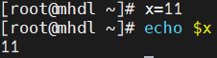
- 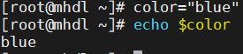
- 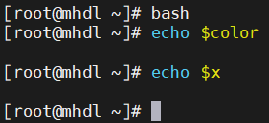
As you can see, in another session of terminal the previous variables cannot be found.
- We just need to open `/etc/profile` or `/etc/bashrc` file and add this line to end of the file:
export mydata=/opt/mydata. Then save and quit the file.
- We need to run `source /etc/profile` command.
- ~/.bashrc, ~/.bash_profile
- /etc/profile, /etc/bashrc

- 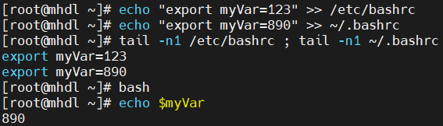
As you can see, the user specific variable wins. Because initially the global variables are loaded, then user specific variables. Thus, user specific ones override the global ones. However, we need to put the variables to end of the file, especially in bashrc, it is better to prevent system confusions.
- We can use `env` or `printenv` command for it.
- 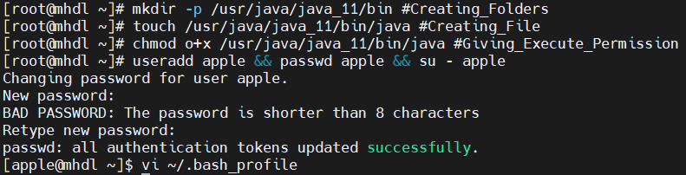
First, we create a `/usr/java/java_11/bin` folder and `java` file inside it. To be able to create anything in `/usr/`, we need to have permissions, so I just did it as a root.
Then I created a user and gave him password and switched it to him.
Then opened its `~/.bash_profile` file and add these lines:
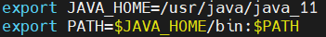
Then I need to re-login or just run `source ~/.bash_profile` to allow system to read the changes in `~/.bash_profile` file.
Then we can just run and check:
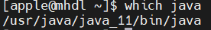

Task 2
- An inode is a data structure in Linux file systems that stores info about files, but not the file name and not the actual data itself. It stores:
- File type (whether it is a regular file or directory or more)
- Its permissions
- The count of hard links
- User and primary
- Timestamps (created or modified time)
- Pointers to the disk blocks (clusters) where the real data is stored

- 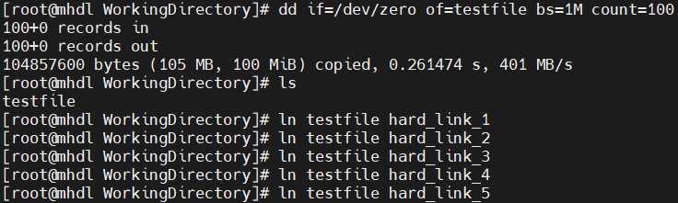
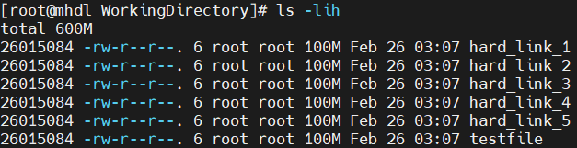
I add `-h` option to make it more human readable.

7)
a) Overall, only 100 MB size, because creating hard links does not allocate new space from the dist, they just are connected to inode of main file. That is why space stays the same.
b) Nothing happens, hard links stay the same and keep the data. The data is completely lost only in the main file, and all its hard links are deleted.
c) File type; permissions; hard link count; user and group; timestamps (created and modified time); pointers to disc blocks where the real data is stored.
d) A hard link points directly to the inode of a file. The inode is stored inside the filesystem of that disk (or partition). Inodes are unique only inside the same filesystem, so you cannot link across filesystems/disks.
e)
/boot is on one filesystem (one “disk area”)
/opt is on another filesystem (often a separate partition)
Hard links point directly to the inode of a file, which exists only inside the same filesystem. So we cannot create hard link of file in different disks.
f) 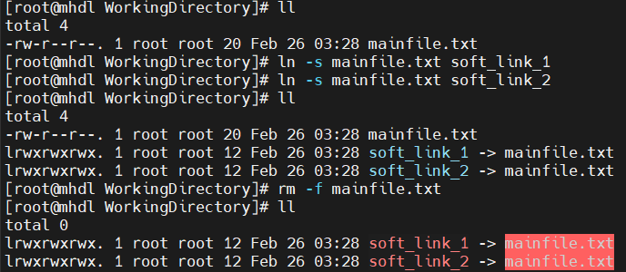
When we remove original file, the soft links become meaningless and data becomes removed. When we try to cat softlinks:
